Capstone Planning Document

Description:
A robot who is staying in the castle along, wish to have emotions. He used to live with a family. But one day they left the castle and left the robot along. With the power of the robot get less and less, the robot want to have emotions at the last time of his Artificial life. And he recall the memory of living with the daughter of his master. Form the different scenes of his memory, he gets different color balls which are represent different emotions.

___Golden ----- happy ------meet the girl
___Green ------ Fear -------the girl in the dark night
___Red -------- Angry ------the girl is attacked by scary animals
___blue ------- Sad --------the girl leave the castle

the player must interact with the girl to get the emotional ball. And player can also collect the things that left behind in the castle to know what happening about the girl’s family.
Besides the different emotional ball can give the robot different abilities.

___Happy : motivation to live - make the player to move
___Fear : the night before the dawn - make the night change to daytime
___Angry : the power to protect ourselves and our family - give player a sword to kill the scary animals
___Sad : The unforgettable memory - give player a light to recall the memory

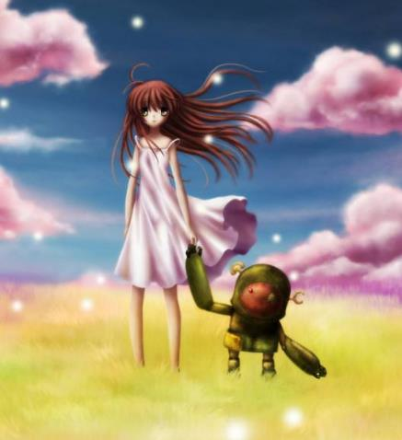

Features And Dependencies:
1. 3D Models + Animations (Reference Images)
a. A Medieval Castle
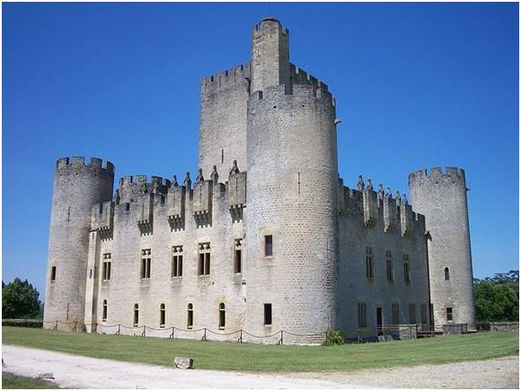
b. A model of a girl with abundant Animations
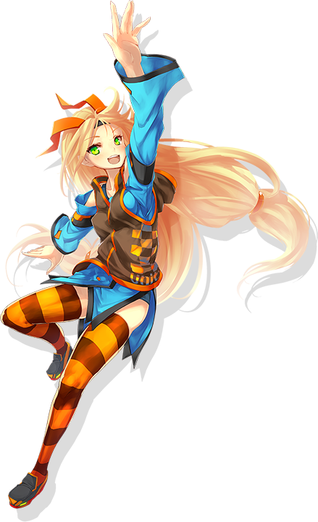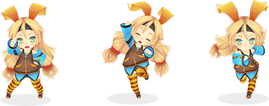
c. A model of girl’s family


d. A model of a robot with IK Animations
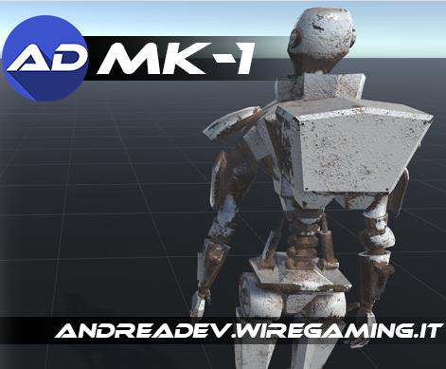
e. A model of scary animal
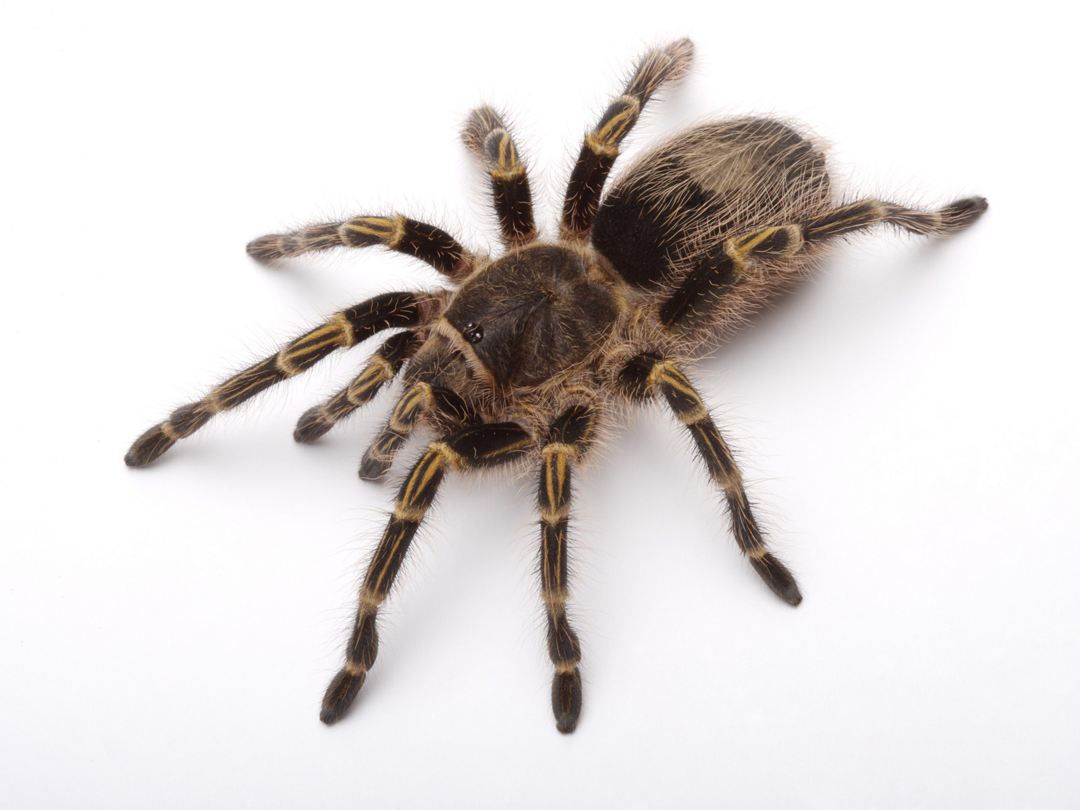

2. Game Loop
a. The robot(player) awake and remember the gift which is given by the girl.--->Get the happy ball.
b. The robot(player) go on patrol in the dark night and calm down the frightened girl →Get the fear ball.
(1)Calm down ---→stay with her for a while.
c. The robot(player) using a sword to protect the girl from the scary animal.-→Get the Angry ball.
(1)Make the enemies more intelligent.
(2)If the robot can’t protect the girl, game over and restart.
d. The robot(player) remember the scene of girl’s family leaving.
e. The four emotional balls combine and give the robot emotions.
f. The girl come back.

3. Other Effects
a. Using the UI and sounds to guide the player.
b. Collections with words can tell player the whole story. Also the collections should be pointed out easily.
c. Divide the castle into different part to explore.

Capstone Scoping
Features And Dependencies:
1. 3D Models + Animations (Reference Images)
a. A Medieval Castle
Revised: Will use a Medieval Castle provided in Unity Asset Store.
b. A model of a girl with abundant Animations
Revised: Will use Unity-Chen provided by unity.
c. A model of girl’s family
Revised: the girl can represent her family.
d. A model of a robot with IK Animations.
Revised: the IK is not well supported with steamVR, it looks a little weird.
e. A model of scary animal.
Revised: Can’t find the huge insect model, and using a lizard instead(free in Asset Store).

2. Game Loop
a. The robot(player) awake and remember the gift which is given by the girl.--->Get the happy ball.
Revised(2017.09.07): It’s hard to make a feeling of waking up with VR, and the robot doesn’t need sleep. So it’s better to begin the game with an erect posture.
Revised(2017.09.08): It’s no need to make the player realize that it just a memory. which may reduce the immersion. So I make the scene looks like the girl is back.

b. The robot(player) go on patrol in the dark night and calm down the frightened girl →Get the fear ball.
Revised(2017.09.11): I should give a time for player to explore the castle and collect the collections. So before the dark night, it should become nightfall.
(1)Calm down ---→stay with her for a while.
Revised(2017.09.15): Not only Stay with her, and also look at her.

c. The robot(player) using a sword to protect the girl from the scary animal.-→Get the Angry ball.
Still planning this.
(1)Make the enemies more intelligent.
Revised(2017.09.12): using the Unity Navigation to do this.
Revised(2017.09.14):it’s not intelligent enough, writing a AI script to make them can avoid player when player is near the girl.
Revised(2017.09.18):Add a HP canvas to show lizard’s HP. If the robot can’t protect the girl, game over and restart.
Revised(2017.09.18):Add a HP canvas to show girl’s HP.

d. The robot(player) remember the scene of girl’s family leaving.
Revised(2017.09.06): the girl can represent her family.
Revised(2017.09.12): using a video to recall this memory.

e. The four emotional balls combine and give the robot emotions.
Still do this.

f. The girl come back.
Revised(2017.09.13):the girl come back can become the truth end with collecting all collections.

3. Other Effects
a. Using the UI and sounds to guide the player.
Still do this.

b. Collections with words can tell player the whole story. Also the collections should be pointed out easily.
Revised(2017.09.16): Creating a shader to pointed out the collections at night.

c. Divide the castle into different part to explore.
Revised(2017.09.10): Reuse the different part of castle.

